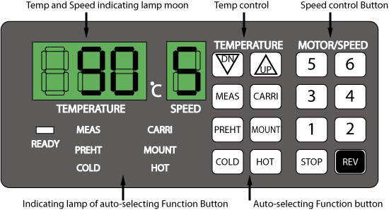
jCharacteristics

Uniformity of Lamination
Equipped 6 "CERACON-roller" and "Motor" run with "D.C
Electric Power-Steady Voltage Circuit" , this laminator transfers the heat quickly and steadily into the each roller and runs the roller smoothly, so that you can get a fine lamination work.

High Performance
With use of microprocessor, optimum laminating tempeature and roller speed can be automatically selected,appropriated for various types oflaminating.

Convenience
Due to its compact and elegant design, it' s convenient to be used at office,photo studio, and other places.
This machine also can easily be displaces.

Safety
User can be protected in case of accident such as electrical shock and heat from the laminator, especially those body and case parts(which are side and control panel made of plastic materiais) that have contact with laminator.

Power saving
Due to the lower operating temperature and automatic control of speed and temperature, there is no unnecessary power consumption.

Soft-Touch control control panel & Alarm System
All functions are controlled by "Soft-Touch Button" . And
the signal light & sound alert you for the changes of mode.

Control Panel

Functions and Operations of control pannel

A. Indicating lamp Functions
Following indicating lamp is lit if function buttons are pressed accordingly

TEMPERATURE
Indicate temperature
Number upon indicates “present temp”, or “set temperature”.



SPEED
Indicate speed
Number upon indicates "Running speed" of the rollers.

COLD
Indicate currently chosen function is cold (No- Heat)" laminating function.

MEAS
Indicate lamp "present temperatrue" of the rollers.

PREHT
Indecate currently chosen function is "Pre-Heat" function.

HOT
Indicate currently chosen function is "Hot (Heat)" Laminating
function.

MOUNT
Indecate currently chosen function is "Mountinq" function.

CARRI
Indecate currently chosen function is "Matting" function

B. Auto-SelectingFunction

COLD
This function can be seleced upon laminating Photonex cold film, and temperature and speed of “0” are automatically set when selected.
If present temp is above 60°…, temp "0" & speed "2" are selected to protect the rollers.
"Cold" Laminating function will be automatically selected when power switch is turned on,







HOT
This function can be selected upon laminating normal film 80mic (Low temp film), and temp of "90" and speed of "5" are automatically set when selected. Under this condition, mormal copying paper of 100mic(80g) can be laminated with 80mic film(Low temp film)

MOUNT
This function can be selected upon laminating hard board types with more than 1 mm of thickness, and temp. "130" & speed "1" are automatically set when selected. Under this condition, hard board with 2mm thickness, can be laminated and mounted with 100mic film.

CARRI
This function can be selected upon laminating With Matting film, and temp of 110 and speed of 2 are automatically set when selected. Under this condition, copies of pictrues, photographs, can be matt finished.

PREHT
This is stand-by function- that can be selected during intervals of long trine operanon.
Temp of "80" and speed of "2" are set automatically, and the motor turn on to protect the rollers, unil another mode to be selected.

REDY
This lamp indicates real temp of the rollers. Changes of states according to temp of the rollers are as following.
Off- temp of the roller is below set temp.
Blinking-temp of the roller is above the set temp. On - present and set temp of the roller are identical. this is ideal condition for laminating since set temp is continuously mainteined

C. Temperature Control

1. These can be used for increasing or decreasing temperature manually.
The temp can be increased or decreased by unit fo 1℃when these buttons are pressed.
2. The range of temp that can be adjusted manually is 0℃~160℃ and once it reaches the limit, warning "beep" will be heard, and the temp is not increased more to protect the machine.

MEAS
This can be selected to check out present temp of the rollers.

Present temp is displayed tor 3 seconds and disappears.

D. Motor! Speed control

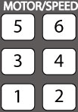
Speed/Motor
1. Speed of the rollers can be adjusted manually by using these Buttons.
2. Speed control from 1-6 is available, so proper speed can be selected for laminating


STOP
1. This can be selected to stop rolling of the rollers.
2. The rolling of rolIers is stopped while this button is pressed.
* To proteet the rollers, please avoid manually stopping the rollers for long time when the temp of the rollers, is above 90℃


REV
1. This can be selected to reverse the revolution of the rollers.
2. Correction of mis-feed and cleaning of the rollers can be done since the rolling is reversed while this button is pressed.

Cold Lamination

Cold lamination is the laminating method that does not heat-damage the contents to be laminated. Since the method employs photonex cold film with out any heat applied

A. Cold laminating an Initial Stage

1. Turn on the power switch located rear of the machine.
2. Cold mode is automatically set,and set temp. "0" and speed "0" of cold mode are displayed on temp and speed indicating lamp room.
Also the cold indicating lamp and ready lamp are lit at the same time .
3. Please set the speed to "2" or" 3" manually in order to perform cold lamination.

B. Cold laminating when the temp is above Hot laminating mode.

* lamination must be performed under temp of 30℃the temp must be confirmed under 30 'C by pressing "MEAS" button in oredr to perform cold lamination.

1. If cold mode is selected during motor is operating.
Temp "0", speed "2" is set and the roller is in slow operation until temp. reaches below 60℃, then it stops and shows speed of "0" User has to wait until temp reaches below 30℃, then manually set speed to "2" or "3" in order to operation.

Hot Lamination

A. How to turn on the machine

1. Turn on the power swich located rear of the machine.
2. Cold mode is automatically set, and set temp “0” and speed "0" of cold mode is displayed on temp and speed indicating lamp room. .
Also geen ready lamp and cold indicating lamp is lit at the same time.
3. User will press the hot mode button; then temp “90”. speed “0” is automatically set, ready is off, and hot indicating lamp is lit at the same time.
If temp of the roller reaches above 60°…, the speed becomes “5” and start to roll.
4. Afer a while, ready lamp is lit when temp of the roller reaches the set Temperature, th en user starts laminating.

B. How to operate lamination

1. Please content into the sealed laminatinq pouch film.
2. The pouch film should be at least 3mm bigger than the content inserted.
3. Pouch film with the content inserted should be placed on to front panel of laminator and put in the roller.
4. Do not push in the pouch forcefully or tilted, the lamination result may be crooked or wrinkled.
5. To check out overall laminating condition, just laminate about 2-3 pouches first. If when it would be fine, continue laminating others.
6. If laminating result is hagy(due to low temp), increase temp or slow down speed of the rollers in opposite case, if user gets burnt or crooked lamination result, decrease temp or increase speed of the rollers.
7. If user wishes to laminate faster, user adjust manually temp and speed.
8. If user wishes to stop rollers discretelly during operation, please press the "stop" button.
* If the rollers stopped for long time, the lifetime of the rollers can be significently reduced.

C. How to finish up lamination

1. Press "Cold" button to turn off the machine. Temp "0", speed "2" will be displayed on temp and speed indicating lamp room.
Temp will be lowered gradually and once it reaches 60℃ the rollers stop automatically.
2. When the motor be stopped automatically, turn oft the power switch.
* In order to extend the lifetime of the roller, select cold mode first, then turn off the power switch when the tamp is below 60℃ (Roller stop)
3. If the machine will not be used for long time, upplug the power cord.

Laminating Temp And Speed

● Standard: Temp 90, Speed 5
80 mie(Low temp film), 100 mic paper(80g)
This is set automatically as standard, when hot mode button is pressed. If the thickness of film or paper is defferent from the standard, just adjusting laminating speed sufficiently.

A. Laminating speed can be adjusted proportional to the thickness of film or paper as following.

1. With 80mic film as a standard, 20mic of thickness corresponds to 1 unit step of speed.
2. With 100mic paper as a standard, 25mic of thickness corresponds to 1 unit step of speed

B. If combination of film and paper is thinner than 1 step or thicker than 4 steps, adjust laminating temperature.

Change of step according to temperature
Temp  ( ˚C ) | 70 | 80 | 90 | 100 | 110 | 120 | 125 | 130 | 135 | 140 | 145
Speed  (step) | -4 | -2 | standard | +1 | +2 | +3 | +4 | +5 | +6 | +7 | +8
ex) When laminating 125mic film and 150mic paper at temp of 100℃
●temp: + 1 step(Refer to tabie), ● Paper: -2step(100-150/25=-2)
●film: -2.2 step(80-125/20=2.25) So after all, select speed(1)
which is 4step below( + 1-2-2.25=-3. 75a)
* Remark : Please don' t change the Temp unless the thickness is for thicker than standard(80mic/100mic)

Tips for achieving perfect lamination

1. Unless sealed pouch is used, thereis possibility that film can be jammed or sticked to the rollers.
2. Using other than recommended films or poor quality films can cause break-down of the machine.
3. If the film is ont fed straight, Iinings or wrinkles may appear on the film.
4. If the content is inserted further the 3mm from the sealed edge of pouch, film may be jammed against front roller and both ends may be folded during lamination.
5. Finish of the edges of. laminated pouch may not be strong if an content thicker than 300mic is laminated.
6. Laminating content of below 150mic or film of below 80mic, specially under 50mic thickness of PET.
Low-cost films may be curled. So lamination at relatively temp, (arond 80 ℃) or using separate carrier are recommeded
7. If lamination result is hazy or doesn' t show good adhesion, reduce the speed by 1 step.
8. If lamination result is burnt to crooked, increase the speed by 1 step .
9. If the temp is too high or speed is too low, film can be wrapped around rollers. In that case user should reverse the rollers, remove the film, and wipe out adhesive on the rollers.
10. Upon laminating irreqular surface such as originals with max. Speed initially, then laminate again with reqular speed to prevent wrinkling.
11. When turning off the power of the machine, press "cold" button fist and wait until roller is spopped at temp below 60℃. Then turn off the power switch.

* Please be careful of followings.
1. Before opening cover of the machine, please alert the electrical shock and the fact
that rolling parts are present.
2. Do not operate the machine around inflammable objects.
3. Prevent penetration of water and other liquids into the machine.
4. Do not operate the machine forcefully.
5. Materials with rough surface or heavy thickness can cause destruction of the rollers and gears in the machine.

How to Perform Mounting
(Temp. 130℃, Speed 1)

Mounting is a laminating method that enables pictures, drafts, photographs and other to be attached onto hard board or aluminum plate, so they een be used as display or exhibition items.

1. Please select the mount mode. then temp 130 ℃, and speed "1" is selected automatically, also the mount indicating lamp is Iit out the same time.

2. After a while ready lamp is lit, then begin lamination.

3. Cut up both film and photonex film, or other laminating film into appropriate size for the content to be laminated.

4. Spread both film over board or aluminum plate and place the content over it. Then place photonex film or other laminating film over them and feed them into laminator.
Content
Bot Film
Hard board

Lamininating film

5. Hold the ends of film tightly when the film is inserted between the rollers.
MRF
Content
Carrier

How to Perform Matting(carrier)
(carrier 200mic, Temp. 110 ℃, Speed 2)

1. Please press the carrier mode button, then temp "110 ℃" , speed "2" is
selectedautomatically. The carrier indicating lamp is lit at the same time also and after a while ready lamp is lit, then begin laminating.
2. Place matt finish release film(MRF) over copy to be processed. Insert-them into a carrier and run them through laminator after it cools off, peel off the MRF.
3. If the film has contact with the rollers, it will stick right on the rollers. To aboid this,
a carrier must be used. If the carrier is relatively thin, laminate with high speed.
* when MRF runs in between the roller, it gets stretched as much as 5%(about 1 cm, per 3cm) so use a carrier at least 1.5cm bigger than the film and content(copy).

How to perform hot-Transferring
(Temp. 130 ~ 140℃, Speed 2 ~ 4)

It' s also possible to make fantastic displays with transfer paper of which copies or prints can be laminated onto cloth, metals, plastics, papers and others.
First, copy or print black-and-color copies, color laser and off set prints, silk prints, design drafts and others onto tranfer paper.
Place it over material to be transferred onto, and run them through laminator to complete the transferring .

* Principle of transferring.

Toner becomes an adhesive when heat is applied. Using this principle, the toner on the original melts and sticks to transparency film to be transferred onto when they are fed together into laminator

General Maintenance

Reqular clean- up is essential in oredr to prevent the adhesive of film being sticked on the rollers ..

1. For cleaning rollers, apply proper amount of kerosene on the rollers when they are not hot. After a while, wipe thern carefully with rough cloth.
* Upon cleaning, please cover the parts with civcuit board to prevent penefration of foreign object.
(It is main cause of circuit mal - functioning)
* please be careful not to demage Roller.

2. User may clean the outer surface and case of this product with dry coloth and wax.

Trouble shooting guide

Problem | Causes | Remedy
Temperature  Not increasing | Main fuse may be out | Check and replace it
Temperature  Not increasing | Power cord may be improperly plugged | Check and replace it
Roller not working  When temperature  About at 60℃ | “Stop” Button may have been pressed after a mode is selected. | Press motor speed button
Cannot select any  Mode | Possibility of  Wiring between main circuit board or operation circuit board disconnected | Check for connection
Bad lamination | Burnt or curled | Decrease temperature or increase speed slightly
Bad lamination | Weak adhesion | Increase temperature or Decrease speed slightly
Lamination  Temperature not  Regular | Roller electric brush may be broken | Call for repair service
Rollers not  Running | Temperature of the roller not yet reached to 60℃ | Wait a while
Rollers not  Running | When the stop button pressed | Press motor speed button
Rollers not running  And motor is running | Circuit bolts on gear ard loose | Call for repair service
Fuse keeps on  Getting burnt | Circuit board damaged | Call for repair service
Excessive noise | Gears no running smoothly | Call for repair service
Laminating film  jammed | Rear panel may be out of position | Reposition it properly

Name of Diagram Parts
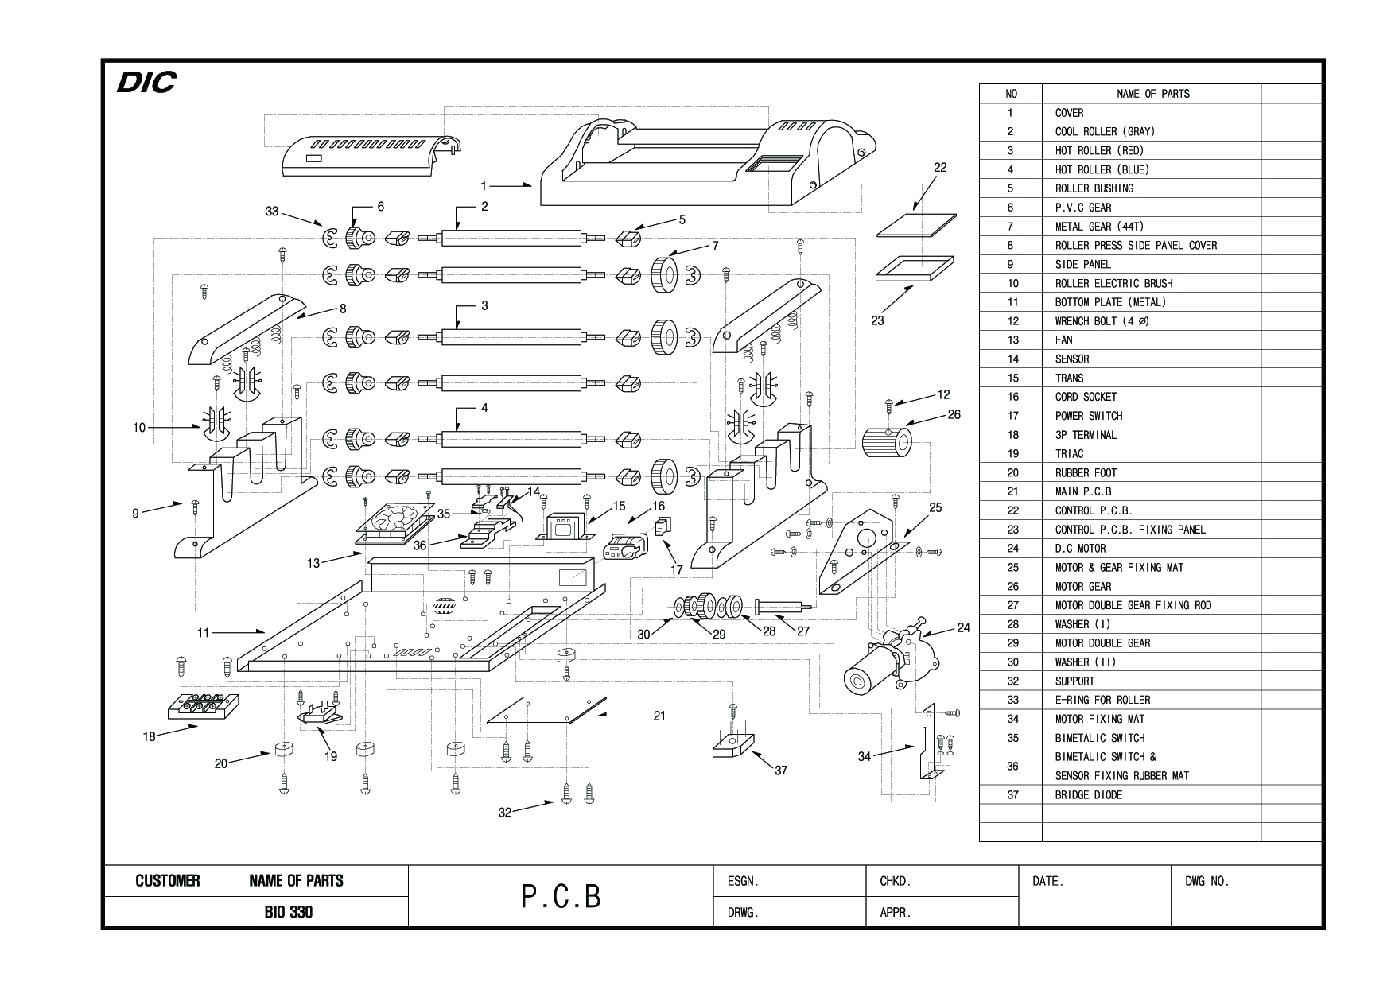

Disjoint and Assembly of Roller
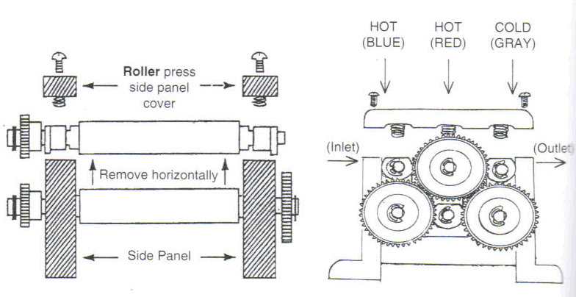
1. Turn off the power S/W and wait until the Roller get cold.
2. Pull out the bolt in side of the machine and take off the cover.
3. Please pull out the bolt on the Roller press side panel cover slowly and alternately.
4. Hold the Roller up straightiy from the side panel. (Take notice the side panel' s demage.)
5. When you construct the Roller on the side panel again, You have to construct the Roller inversely as below.
1) Please pay attention not to be folded up the Electrical Bursh( )
2) Please have to reassemble the gears each other.
3) A situation of Rollers does not be exchanged each other.
ex) Front (HOT ROLLER) - Blue color silicon rubber.
Middle (HOT ROLLER) - Red color silicon ruber.
Rear (COOL ROLLER) - Gray color silicon rubber.

*CAUTION :
If the Gray(Cool) roller is exchanged for the others (Hot rollers), The Hot rollers and electric network shall be burnt and damaged .

